SAP PowerDesigner
Object-Oriented Model Report

Model: Use Case Diagram_1
Report: Full Object Report



Author: Lenovo
Version:
Date: 5/10/2026
Summary:

Table of Contents

The 'Table of Contents' field needs to be updated!

Specifications
Insert specifications here...

Model information

Card of model Use Case Diagram_1
Name | Use Case Diagram_1
Code | Use_Case_Diagram_1
Comment

OOM Diagrams

Model level diagrams

Diagram Use Case Diagram_1
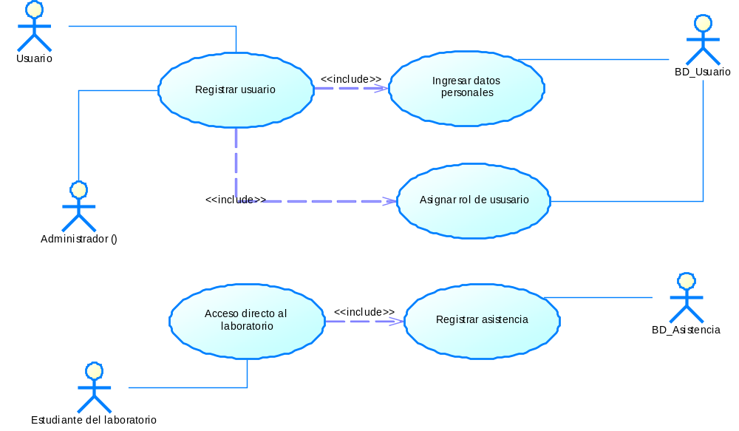

Common objects

Actors

Model level actors

List of actors
Name | Code | Parent
Administrador () | Administrador___ | Object-Oriented Model 'Use Case Diagram_1'
BD_Asistencia | BD_Asistencia | Object-Oriented Model 'Use Case Diagram_1'
BD_Usuario | BD_Usuario | Object-Oriented Model 'Use Case Diagram_1'
Estudiante del laboratorio | Estudiante_del_laboratorio | Object-Oriented Model 'Use Case Diagram_1'
Usuario | Usuario | Object-Oriented Model 'Use Case Diagram_1'

Dependencies

Model level dependencies

List of dependencies
Name | Code | Influent Object | Dependent Object
Dependency_1 | Dependency_1 | Ingresar datos personales | Registrar usuario
Dependency_2 | Dependency_2 | Asignar rol de ususario | Registrar usuario
Dependency_3 | Dependency_3 | Registrar asistencia | Acceso directo al laboratorio

Dependency Dependency_1

Card of dependency Dependency_1
Name | Dependency_1
Code | Dependency_1
Influent Object | Ingresar datos personales
Dependent Object | Registrar usuario

List of diagrams containing the dependency Dependency_1
Name | Code
Use Case Diagram_1 | Use_Case_Diagram_1

List of extended attributes of the dependency Dependency_1
Name | Data Type | Value | Target Name
CommunicationDataType | CommunicationDataTypes |  | Technical Architecture Modeling (TAM)
CommunicationProtocol | CommunicationProtocols |  | Technical Architecture Modeling (TAM)

Dependency Dependency_2

Card of dependency Dependency_2
Name | Dependency_2
Code | Dependency_2
Influent Object | Asignar rol de ususario
Dependent Object | Registrar usuario

List of diagrams containing the dependency Dependency_2
Name | Code
Use Case Diagram_1 | Use_Case_Diagram_1

List of extended attributes of the dependency Dependency_2
Name | Data Type | Value | Target Name
CommunicationDataType | CommunicationDataTypes |  | Technical Architecture Modeling (TAM)
CommunicationProtocol | CommunicationProtocols |  | Technical Architecture Modeling (TAM)

Dependency Dependency_3

Card of dependency Dependency_3
Name | Dependency_3
Code | Dependency_3
Influent Object | Registrar asistencia
Dependent Object | Acceso directo al laboratorio

List of diagrams containing the dependency Dependency_3
Name | Code
Use Case Diagram_1 | Use_Case_Diagram_1

List of extended attributes of the dependency Dependency_3
Name | Data Type | Value | Target Name
CommunicationDataType | CommunicationDataTypes |  | Technical Architecture Modeling (TAM)
CommunicationProtocol | CommunicationProtocols |  | Technical Architecture Modeling (TAM)

Use case objects

Model level use cases

Use case association Association_1

Card of use case association Association_1
Name | Association_1
Code | Association_1
Parent | Object-Oriented Model 'Use Case Diagram_1'
Destination | Registrar usuario
Source | Usuario

Use case association Association_2

Card of use case association Association_2
Name | Association_2
Code | Association_2
Parent | Object-Oriented Model 'Use Case Diagram_1'
Destination | Registrar usuario
Source | Administrador ()

Use case association Association_3

Card of use case association Association_3
Name | Association_3
Code | Association_3
Parent | Object-Oriented Model 'Use Case Diagram_1'
Destination | Acceso directo al laboratorio
Source | Estudiante del laboratorio

Use case association Association_4

Card of use case association Association_4
Name | Association_4
Code | Association_4
Parent | Object-Oriented Model 'Use Case Diagram_1'
Destination | Ingresar datos personales
Source | BD_Usuario

Use case association Association_5

Card of use case association Association_5
Name | Association_5
Code | Association_5
Parent | Object-Oriented Model 'Use Case Diagram_1'
Destination | Asignar rol de ususario
Source | BD_Usuario

Use case association Association_6

Card of use case association Association_6
Name | Association_6
Code | Association_6
Parent | Object-Oriented Model 'Use Case Diagram_1'
Destination | Registrar asistencia
Source | BD_Asistencia

List of use cases
Name | Code | Parent
Acceso directo al laboratorio | Acceso_directo_al_laboratorio | Object-Oriented Model 'Use Case Diagram_1'
Asignar rol de ususario | Asignar_rol_de_ususario | Object-Oriented Model 'Use Case Diagram_1'
Ingresar datos personales | Ingresar_datos_personales | Object-Oriented Model 'Use Case Diagram_1'
Registrar asistencia | Registrar_asistencia | Object-Oriented Model 'Use Case Diagram_1'
Registrar usuario | Registrar_usuario | Object-Oriented Model 'Use Case Diagram_1'

Use case Acceso directo al laboratorio

Card of use case Acceso directo al laboratorio
Name | Acceso directo al laboratorio
Code | Acceso_directo_al_laboratorio
Parent | Object-Oriented Model 'Use Case Diagram_1'

List of all dependencies of the use case Acceso directo al laboratorio
Name | Code | Class Name
Association_3 | Association_3 | Use Case Association
Dependency_3 | Dependency_3 | Dependency

Use case Asignar rol de ususario

Card of use case Asignar rol de ususario
Name | Asignar rol de ususario
Code | Asignar_rol_de_ususario
Parent | Object-Oriented Model 'Use Case Diagram_1'

List of all dependencies of the use case Asignar rol de ususario
Name | Code | Class Name
Association_5 | Association_5 | Use Case Association
Dependency_2 | Dependency_2 | Dependency

Use case Ingresar datos personales

Card of use case Ingresar datos personales
Name | Ingresar datos personales
Code | Ingresar_datos_personales
Parent | Object-Oriented Model 'Use Case Diagram_1'

List of all dependencies of the use case Ingresar datos personales
Name | Code | Class Name
Association_4 | Association_4 | Use Case Association
Dependency_1 | Dependency_1 | Dependency

Use case Registrar asistencia

Card of use case Registrar asistencia
Name | Registrar asistencia
Code | Registrar_asistencia
Parent | Object-Oriented Model 'Use Case Diagram_1'

List of all dependencies of the use case Registrar asistencia
Name | Code | Class Name
Association_6 | Association_6 | Use Case Association
Dependency_3 | Dependency_3 | Dependency

Use case Registrar usuario

Card of use case Registrar usuario
Name | Registrar usuario
Code | Registrar_usuario
Parent | Object-Oriented Model 'Use Case Diagram_1'

List of all dependencies of the use case Registrar usuario
Name | Code | Class Name
Association_1 | Association_1 | Use Case Association
Association_2 | Association_2 | Use Case Association
Dependency_1 | Dependency_1 | Dependency
Dependency_2 | Dependency_2 | Dependency

List of use case associations
Name | Code | Parent | Destination | Source
Association_1 | Association_1 | Object-Oriented Model 'Use Case Diagram_1' | Registrar usuario | Usuario
Association_2 | Association_2 | Object-Oriented Model 'Use Case Diagram_1' | Registrar usuario | Administrador ()
Association_3 | Association_3 | Object-Oriented Model 'Use Case Diagram_1' | Acceso directo al laboratorio | Estudiante del laboratorio
Association_4 | Association_4 | Object-Oriented Model 'Use Case Diagram_1' | Ingresar datos personales | BD_Usuario
Association_5 | Association_5 | Object-Oriented Model 'Use Case Diagram_1' | Asignar rol de ususario | BD_Usuario
Association_6 | Association_6 | Object-Oriented Model 'Use Case Diagram_1' | Registrar asistencia | BD_Asistencia

